Word of Life: May 2018
Recommended dates are provided, but you are welcome to use these materials at any time!
Intercessions for Life

May 6th Sixth Sunday of Easter
For our shepherds:
May their example
guide us in building a culture
that cherishes every human life;
We pray to the Lord:

Seventh Sunday of Easter
(or the Ascension of the Lord, where applicable)
May 13th
May we treat one another with love
that reflects the sacredness of human life;
We pray to the Lord:

May 20th Pentecost Sunday
May the Holy Spirit strengthen us
to share in word and show in action
respect for God’s gift of life;
We pray to the Lord:

May 27th The Solemnity of the Most Holy Trinity
For all people:
May God grant us courage to embrace
his precious gift of life,
even in the most difficult of circumstances;
We pray to the Lord:

Word of Life – May 2018

Bulletin Quotes

May 6th  “Sometimes our actions speak for themselves; other times, words are needed. Whatever the situation, Jesus knows how to speak to each person's heart; we simply need to follow where he leads.”  USCCB Secretariat of Pro-Life Activities  “How to Build a Culture of Life,” www.usccb.org/culture-of-life | 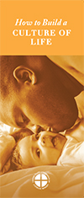  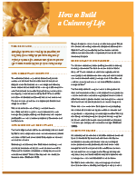  Order Download
May 13th  “We can all help encourage our government and other institutions to support life. They must always aid and support mothers and children, and never offer to pay for the destruction of life as a ‘solution’ to the challenges women face. The call to uphold women’s dignity and well-being, and that of their unborn children, is one and the same.”  USCCB Secretariat of Pro-Life Activities  “Poverty and Abortion: A Vicious Cycle,” www.bit.ly/poverty-abortion | 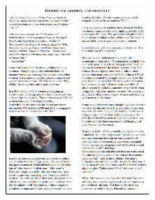  Download
May 20th  “Even among terminally ill patients, a request to die is nearly always a cry for help. … The patient requesting assisted suicide is often asking, ‘Does anyone want me to be alive, or care enough to talk me out of this request and support me through this difficult time?’”  USCCB Secretariat of Pro-Life Activities  “Every Suicide is Tragic,” www.bit.ly/every-suicide-tragic | 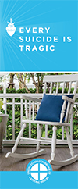  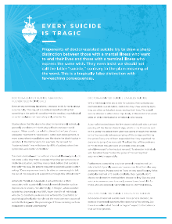  Order | Download
May 27th  “Reflecting on the healed wounds of the Risen Christ, we see that even our most difficult trials can be the place where God manifests his victory. He makes all things beautiful. He makes all things new.”  USCCB Secretariat of Pro-Life Activities  2017-2018 Respect Life Reflection, www.usccb.org/be-not-afraid | 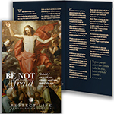  Order Download

Word of Life - May 2018

Bulletin Art
You are welcome to use these and other downloadable images from the online Respect Life image gallery, provided they are not altered in any way, other than the size. Thank you!

Sunday, May 20th, 2018
Featuring “Every Suicide is Tragic”
- Image: English | Spanish
- Article: English | Spanish
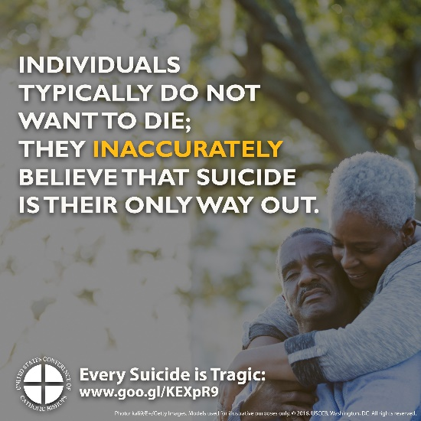

Sunday, May 27th, 2018
- Download Image: English | Spanish
- Reflection: English | Spanish

